Bootstrap guided activity

In this exercise, you will work through a guided exercise where the code is provided. Your job is to enter it and observe the changes in the webpage. Then, once you complete the guided portion, you must complete an “on your own” section where you have to create a responsive grid based off of the instructions. Please be sure to complete both parts of this exercise. You will be graded on the guided portion and the “on your own” section.

# Guided Exercise

In this section you will add the code provided.

1. Please begin by downloading the start file (StartFileGrid.html) and opening it in your favorite text editor.

2. Add the following embedded styles between the style tags in the head section of the html document.

.bg {
background: lightblue;
border: 1px solid black;
}

3. Append the following code to the html document in the body section just after the opening div with a class of container:

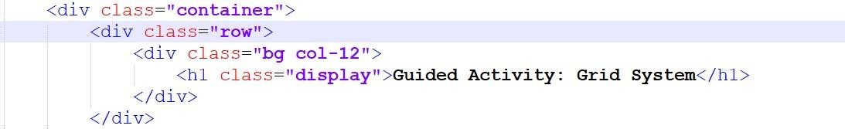

This creates a row with a single column that uses all 12 spaces in the grid.

(You can test your page between steps to see the results).

In the code, below this first row, you will find another div with a class of “row” (shown in the screenshot below). This row contains 4 total columns.

4. Modify each div in the second div assigned the class of row to contain the following classes:

Col-lg-3, col-md-6, col-sm-12, col-12

Do not modify the div assigned the class of row.

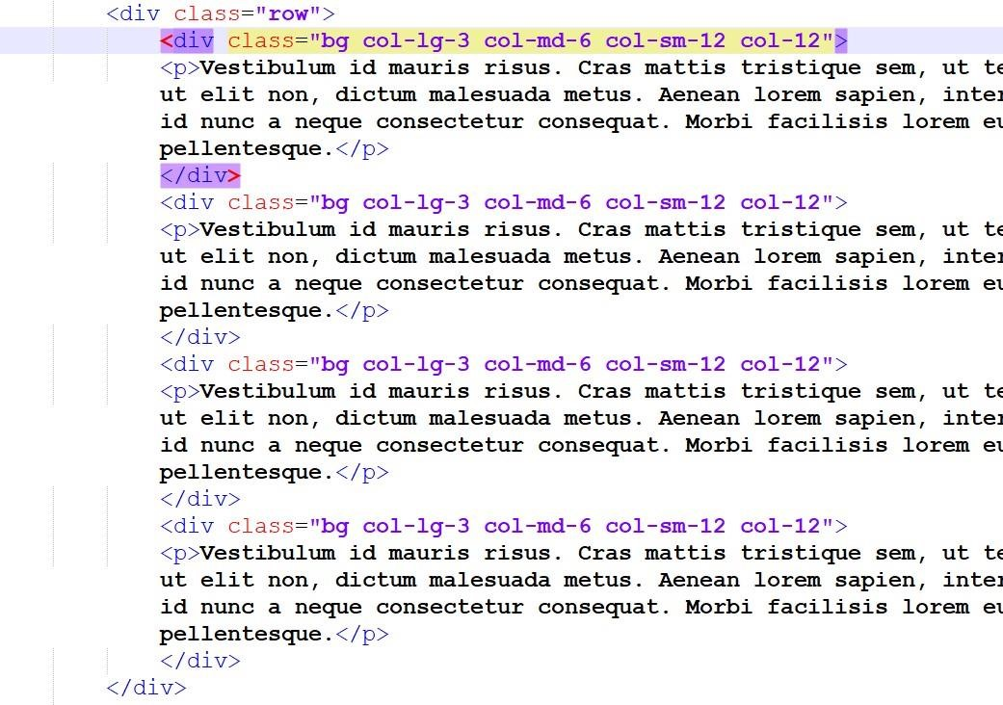

Observe the changes at different screen sizes. You’ll notice that the on large screens, the second row is a 4-column layout where each column takes 3/12 spaces on the grid, on medium screens, it is a 2-column layout where each column takes 2/12 spaces on the grid, and on small screens, it goes to a single column layout where each column takes 12/12 spaces on the grid

# On Your Own

In this section, you will **add** to the existing document and create a responsive grid. (Do not delete the existing code as you will be graded on that portion too).

On your own, you will apply what you know about the grid, and create the following:

1. Create a **new row that contains 3 columns** 
   1. On large screens: the first column will take 2/12 spaces in the grid, the second and third column will take 5/12 spaces in the grid.
   2. On small screens: all columns will take 12/12 spaces in the grid

Below (on the next page) is a screenshot of the desired result for the “on your own” section of this exercise.

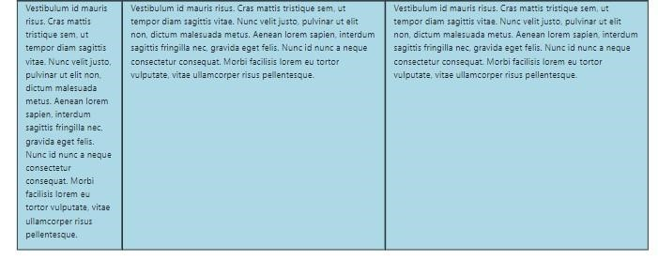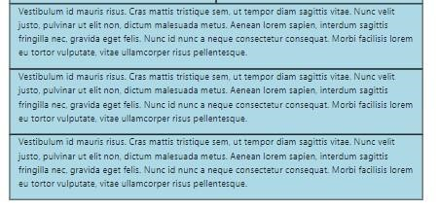

L



arge



screen result



small



screen result



**When complete, zip and upload your files to this dropbox. No need to upload the practice exercise to the server.**